Rahul Kshirsagar
730 Data Science on Block Chain
Project Report

Decentralized Multi-Plan Subscription System Using Smart Contracts
1. Introduction
Blockchain technology has transformed the way digital transactions and services are managed. Traditional subscription systems depend on centralized platforms where users pay through intermediaries such as payment gateways or service providers. These centralized systems often suffer from issues such as lack of transparency, high transaction fees, delayed payments, and the possibility of data manipulation.
A smart contract is a self-executing program stored on a blockchain that automatically enforces the terms of an agreement when predefined conditions are met. Smart contracts enable trustless transactions between users without requiring a central authority.
This project implements a Decentralized Multi-Plan Subscription System using a smart contract deployed on the Ethereum blockchain. The system allows users to subscribe to different service plans by paying cryptocurrency. The contract records subscription details and verifies whether a user's subscription is active or expired.
The smart contract is developed and deployed using the Ethereum development environment Remix IDE, connected through the crypto wallet MetaMask, and deployed on the test blockchain network Sepolia Testnet. Transaction verification and blockchain records can be viewed through the blockchain explorer Etherscan.
This system demonstrates how decentralized applications can manage subscriptions without intermediaries while ensuring transparency, security, and automation.

2. Objective of the Project
The main objective of this project is to design and implement a decentralized subscription platform using smart contracts on the Ethereum blockchain.
The specific objectives include:
• To understand the working of blockchain technology and smart contracts
• To design a decentralized system for managing subscription services
• To allow users to subscribe to different plans using cryptocurrency
• To store and verify subscription details on the blockchain
• To implement automated subscription validation based on expiry time
• To demonstrate how decentralized systems remove the need for intermediaries
This project helps demonstrate the real-world use of smart contracts in subscription-based digital services.

3. Tools and Technologies Used
The following tools and technologies were used in the development of this project.
Remix IDE
Remix IDE is a browser-based integrated development environment used for writing, compiling, deploying, and testing smart contracts written in Solidity.
MetaMask Wallet
MetaMask is a cryptocurrency wallet that allows users to interact with Ethereum blockchain applications and sign transactions.
Sepolia Test Network
Sepolia Testnet is an Ethereum test network used for deploying and testing smart contracts without spending real cryptocurrency.
Etherscan Blockchain Explorer
Etherscan allows users to view blockchain transactions, smart contract details, and account balances.
Solidity Programming Language
Solidity is the programming language used for writing smart contracts on the Ethereum blockchain.

4. System Architecture
The decentralized subscription system works through the interaction between users, smart contracts, and the blockchain network.
The system architecture consists of the following components:
User
The user interacts with the smart contract by subscribing to a plan using cryptocurrency through MetaMask.
Smart Contract
The smart contract manages subscription plans, records user subscriptions, verifies expiry dates, and allows the owner to withdraw funds.
Blockchain Network
All transactions and subscription data are stored permanently on the Ethereum blockchain.
Blockchain Explorer
Transactions and contract details can be publicly verified using Etherscan.
Architecture Workflow
- User connects their wallet using MetaMask
- User selects a subscription plan
- User sends payment through the smart contract
- Smart contract records the subscription details
- Blockchain stores the transaction permanently
- Users can check whether their subscription is active

5. Smart Contract Design
The smart contract implements a decentralized multi-plan subscription system. It allows users to subscribe to three different plans.
Subscription Plans
Plan | Price
Basic Plan | 0.01 ETH
Premium Plan | 0.02 ETH
VIP Plan | 0.03 ETH
Data Structure
The contract uses a mapping data structure to store subscription information.
Each user address is mapped to a subscription record containing:
• Subscription plan
• Expiry timestamp
Key Functions in the Smart Contract
subscribe()
Allows users to subscribe to a plan by sending the required amount of ETH.
checkSubscription()
Returns the subscription plan and expiry date of a user.
isActive()
Checks whether a user's subscription is still active.
withdraw()
Allows the contract owner to withdraw the collected funds.

6. Smart Contract Code
Below is the smart contract used for implementing the decentralized subscription system.
// SPDX-License-Identifier: MIT
pragma solidity ^0.8.20;

contract SubscriptionService {

address public owner;

struct Subscription {
uint plan;
uint expiry;
}

mapping(address => Subscription) public subscribers;

uint public basicPrice = 0.01 ether;
uint public premiumPrice = 0.02 ether;
uint public vipPrice = 0.03 ether;

constructor() {
owner = msg.sender;
}

function subscribe(uint _plan) public payable {

require(_plan >= 1 && _plan <= 3, "Invalid plan");

uint price;

if(_plan == 1){
price = basicPrice;
}
else if(_plan == 2){
price = premiumPrice;
}
else{
price = vipPrice;
}

require(msg.value >= price, "Insufficient payment");

subscribers[msg.sender] = Subscription({
plan: _plan,
expiry: block.timestamp + 30 days
});
}

function checkSubscription(address user) public view returns(uint plan, uint expiry) {
Subscription memory sub = subscribers[user];
return (sub.plan, sub.expiry);
}

function isActive(address user) public view returns(bool){
return subscribers[user].expiry > block.timestamp;
}

function withdraw() public {
require(msg.sender == owner, "Only owner");

(bool success, ) = owner.call{value: address(this).balance}("");
require(success, "Transfer failed");
}
}

7. Implementation Steps
The project implementation involves the following steps.
Step 1: Creating the Smart Contract
A new Solidity file named Subscription.sol was created in Remix IDE. The smart contract code was written to define subscription plans, store subscriber data, and implement required functions.

Step 2: Compiling the Smart Contract
The smart contract was compiled using the Solidity compiler available in Remix IDE. Compilation ensures that the code has no syntax errors and is ready for deployment.
📷 Screenshot : Successful Compilation
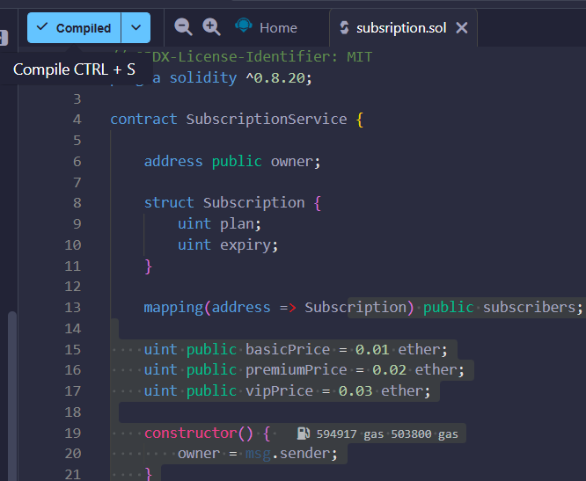

Step 3: Connecting MetaMask Wallet
The MetaMask wallet was connected to Remix IDE using the Injected Provider environment.
📷 Screenshot : MetaMask Connected to Remix
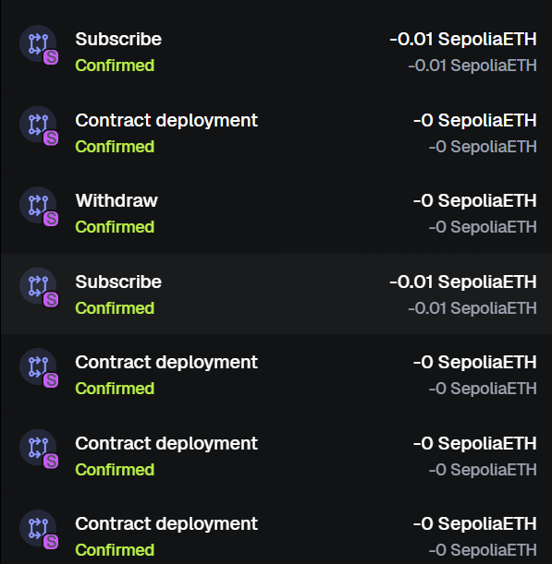

Step 4: Deploying the Smart Contract
The smart contract was deployed to the Sepolia test network. The deployment transaction was confirmed through MetaMask.
📷 Screenshot : Smart Contract Deployment
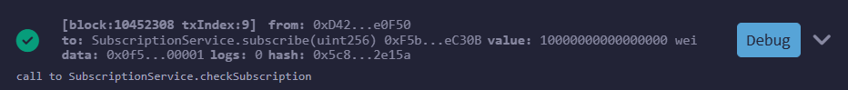
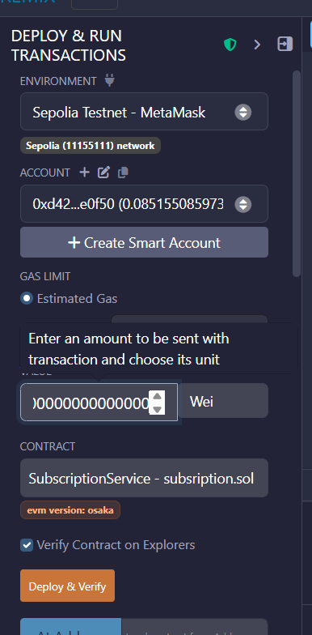

8. Contract Deployment Details
Network Used:
Sepolia Test Network
Platform Used:
Remix IDE
Wallet Used:
MetaMask
Blockchain Explorer:
Etherscan
Contract Address:
0xF5b6C27ABB15d1E69D183e4bdEa8fa362E1eC30B

9. Transaction Execution
Subscription Transaction
A user subscribed to the Basic plan by sending 0.01 ETH to the smart contract using the subscribe() function.
📷 Screenshot : Subscribe Transaction on Etherscan 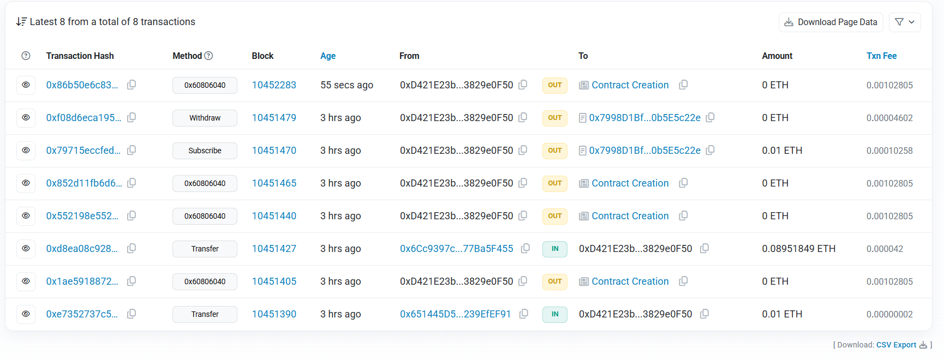

Checking Subscription Details
The checkSubscription() function was executed to retrieve the subscription details of the user.
Checking Active Status
The isActive() function was executed to verify whether the subscription was active.
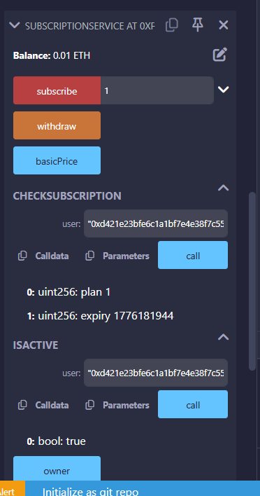
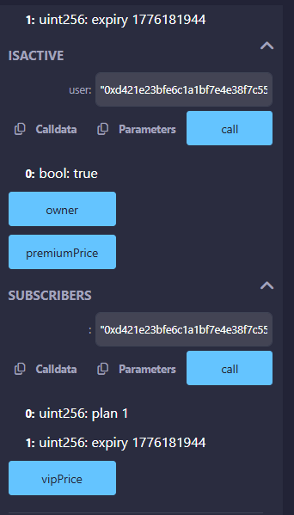

10. Results
The decentralized subscription system was successfully implemented and deployed on the Ethereum Sepolia test network.
The smart contract allowed users to subscribe to different plans by sending cryptocurrency. All subscription data was stored on the blockchain and could be verified through Etherscan.
The system successfully demonstrated:
• Smart contract deployment
• Cryptocurrency transactions
• Storage of subscription data
• Automatic verification of subscription status
• Owner withdrawal of funds

11. Advantages of the System
• Eliminates intermediaries in subscription services
• Ensures transparency and trust
• Automates subscription verification
• Provides tamper-proof transaction records
• Allows global access through blockchain networks

12. Limitations
• Requires cryptocurrency wallets for interaction
• Transaction fees (gas fees) are required
• User interface needs improvement for real-world deployment

13. Conclusion
This project successfully demonstrates the implementation of a decentralized subscription system using Ethereum smart contracts. The smart contract allows users to subscribe to multiple plans and automatically verifies subscription validity using blockchain timestamps.
By deploying the contract on the Sepolia test network, the project shows how blockchain technology can replace traditional centralized subscription systems. The use of smart contracts ensures transparency, security, and automation without the need for trusted intermediaries.
This system highlights the potential of decentralized applications in transforming digital services such as subscriptions, memberships, and online platforms.

14. Deliverables Summary
The final deliverables of the project include:
• Smart Contract Source Code (Subscription.sol)
• Contract Deployment Address
• Transaction Proof from Etherscan
• Screenshots of Implementation Steps
• Working Demonstration of Smart Contract Functions
• Complete Project Report
These deliverables confirm the successful development and deployment of the decentralized subscription system.

